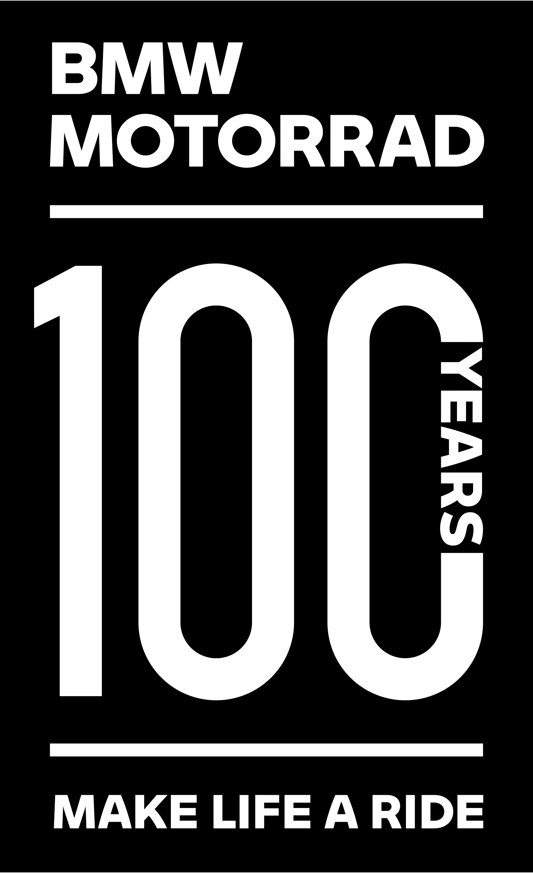 | RAG RALLY  REGISTRATION FORM  (South Island)  Top 10 Holiday Park  Akaroa  Fri 24th – Sun 26th Nov 2023 | 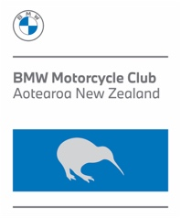

Name/s
Address
Email

BMWMC Mem # |  | Area
Mobile No. |  | Home No.
Registration & Badge fees - Saturday’s BBQ Dinner inc. |  |  | NUMBER | COST / PP | TOTAL
- BMWMC Member |  |  |  | $30.00
- NON BMWMC Member |  |  |  | $60.00
- RAG RALLY Badge |  |  |  | $20.00
This is a BMW Motorcycle Club Qualifying Event TOTAL $
Note: Registration fees are non-refundable (although, special applications may be considered).

Have you already booked you accommodation? |  | Yes No
Please click this link to the Akaroa Top 10 Holiday Park to secure your accomodation. Akaroa Top 10
To help us, please list the names of all persons you have registered in the same cabin with you, thank you.

All attendees are required to complete a Registration form.

DISCLAIMER: This Rally will be run under our BMWMCNZ Risk Management Plan as in the club’s official Newsletter

Please email a scan/photo of all Registration Forms to:  sirag@bmwmc.nz  Registrations close:  Friday 30th October 2023 | Payment by Internet Banking  or by Card online – under Events  BMWMC Account  03-1519-0034447-01  Particulars: SURNAME  Code: SIRAG 2023  Reference: Mobile OR Member # | General enquiries to:  Rally Coordinator  Stephen Parkinson  021 989 092  sirag@bmwmc.nz

